
GARFIELD COUNTY FIRE DISTRICT #1
949 Main St. – PO Box 69
Pomeroy, WA 99347
509-843-1533 Fax: 509-843-9937

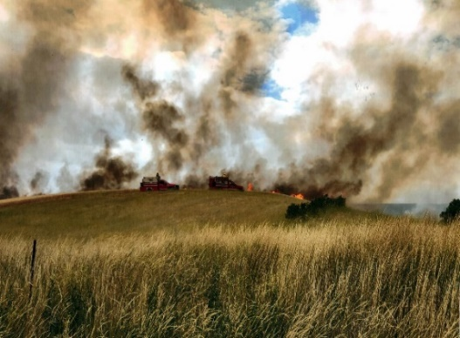
Seasonal Wildland Firefighter

Application Opens: March 9, 2026

Applicant Review: April 6th 2026

Hourly Pay: $26.00 to $28.00 per hour DOQ

About Us:
We are a growing fire and EMS provider in rural southeast Washington and provide fire, rescue, and emergency medical services to almost all of Garfield County, including the City of Pomeroy. This year we are seeking NWCG qualified personnel to staff a Type 6 Engine for state mobilization and national response to have a more robust wildland mutual aid program.
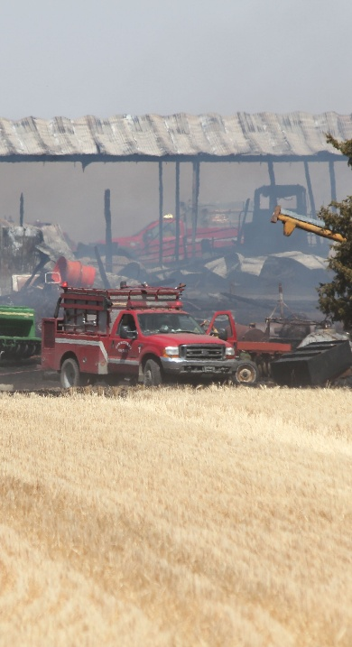
The Position:
We are currently hiring for a seasonal Wildland Firefighter who would be responsible for responding to deployments as well as respond to local fires when not on deployments. The position is full time for 10 weeks but may be extended as needed, dependent on deployments and the fire season. Fire deployments may last 2 weeks or more and require staying on site for that time.

Minimum Qualifications:
NWCG Type 2 Firefighter
Ability to pass an arduous pack test

Preferred Qualifications:
NWCG Type 1 Firefighter
Faller Qualification

To Apply:
Submit a cover letter, resume and application to GCFD 1, PO Box 69, Pomeroy, WA 99347 or to info@garfieldfd1.org .
